**4. Design a mock login page and style it using CSS3. Initially login page should look like the following screen shot.**

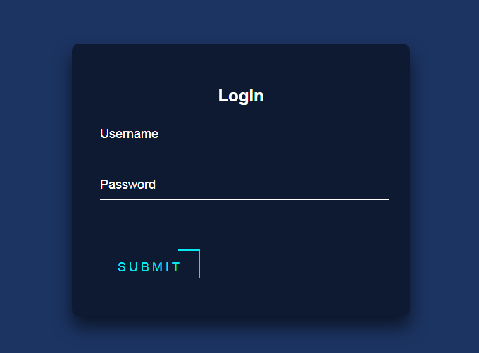

**And while mouse is hovered on SUBMIT button it should look like**

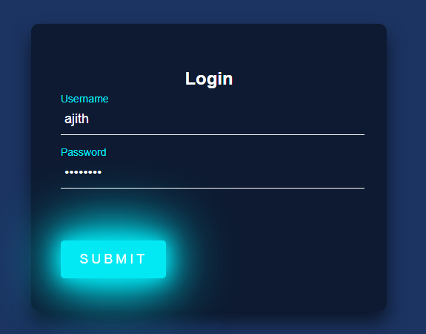

**HTML CODE :( LOGIN.HTML)**

<!DOCTYPE html>

<html lang="en" dir="ltr">

<head>

<meta charset="utf-8">

<title>Mock Login page</title>

<link rel="stylesheet"href="loginstyle.css">

</head>

<body>

<div class="login-box">

<h2>Login</h2>

<form>

<div class="user-box">

<input type="text" class="loginput" required="">

<label>Username</label>

</div>

<div class="user-box">

<input type="password" class="loginput" required="">

<label>Password</label>

</div>

<a href="#">

<span></span>

<span></span>

<span></span>

<span></span>

SUBMIT

</a>

</form>

</div>

</body>

</html>

**CSS CODE (Loginstyle.css):**

body {

font-family: sans-serif;

background:#1c3462;

}

.login-box {

margin: 100px auto;

width: 400px;

padding: 40px;

background: rgba(0, 0, 0, 0.5);

box-shadow: 0 15px 25px rgba(0,0,0,.6);

border-radius: 10px;

}

.login-box h2 {

color: #fff;

text-align: center;

}

.login-box .user-box {

position: relative;

}

input {

width: 100%;

padding: 10px 5px;

font-size: 18px;

color: #fff;

margin-bottom: 30px;

border: none;

border-bottom: 1px solid #fff;

outline: none;

background: transparent;

}

label {

position: absolute; /* position inside another container

using top,bottom,left */

top:0;

padding: 10px 0;

font-size: 18px;

color: #fff;

pointer-events: none;

transition: 0.5s;

}

.loginput:focus ~ label,

.loginput:valid ~ label {

top: -25px;

color: #03e9f4;

font-size: 14px;

}

a {

position: relative;

display: inline-block;

padding: 15px 25px;

color: #03e9f4;

font-size: 18px;

text-decoration: none;

overflow: hidden;

margin-top: 40px;

letter-spacing: 4px;

transition: 0.5s;

}

a:hover {

background: #03e9f4;

color: #fff;

border-radius: 5px;

box-shadow: 0 0 25px #03e9f4,

0 0 50px #03e9f4,

0 0 75px #03e9f4,

0 0 100px #03e9f4;

}

a span {

position: absolute;

}

a span:nth-child(1) {

top: 0;

left: -100%;

width: 100%;

height: 2px;

background: #03e9f4;

animation: btn-anim1 1s linear infinite;

}

@keyframes btn-anim1 {

0% {

left: -100%;

}

50%,100% {

left: 100%;

}

}

a span:nth-child(2) {

right: 0;

top: -100%;

height: 100%;

width: 2px;

background: #03e9f4;

animation: btn-anim2 1s linear infinite;

animation-delay: 0.25s;

}

@keyframes btn-anim2 {

0% {

top: -100%;

}

50%,100% {

top: 100%;

}

}

a span:nth-child(3) {

bottom: 0;

right: -100%;

width: 100%;

height: 2px;

background: #03e9f4;

animation: btn-anim3 1s linear infinite;

animation-delay: 0.50s;

}

@keyframes btn-anim3 {

0% {

right: -100%;

}

50%,100% {

right: 100%;

}

}

a span:nth-child(4) {

left: 0;

bottom: -100%;

height: 100%;

width: 2px;

background: #03e9f4;

animation: btn-anim4 1s linear infinite;

animation-delay: 0.75s;

}

@keyframes btn-anim4 {

0% {

bottom: -100%;

}

50%,100% {

bottom: 100%;

}

}